*“HEART DIAGNOSER”*

##### A PROJECT REPORT

###### **Submitted by**

##### SANIDHYA GUPTA and SANSKAR VIJAYVARGIYA

**Under the guidance of**

### Dr. Ramesh Thakur

**In *partial fulfillment for the VII Semester Examination of***

**M.Tech.(IT)**

**of**

**International Institute of Professional Studies**

**Devi Ahilya Vishwavidyalaya, Indore**

**2022**

**DECLARATION**

I hereby declare that the project entitled “Heart Diagnoser” which is submitted by ***Mr.* *Sanidhya Gupta*** *and* ***Mr. Sanskar Vijayvargiya*** for the partial fulfillment for the award of degree of Master of Technology(IT) 5 Years of International Institute of Professional Studies, Devi Ahilya Vishwavidyalaya, Indore, comprises our own work and due acknowledgement has been made in text to all other material used.

Signature of Student: …………………………

Date: ………………………….

Place: ………………………….

**International Institute of Professional Studies**

**Devi Ahilya Vishwavidyalaya, Indore, M.P.**

**CERTIFICATE FROM GUIDE**

It is to certify that dissertation on “Heart Diagnoser”, submitted by ***Mr.* *Sanidhya Gupta*** *and* ***Mr. Sanskar Vijayvargiya*** for the partial fulfillment for the award of degree of Master of Technology(IT)5 1/2 years of International Institute of Professional Studies, Devi Ahilya Vishwavidyalaya, Indore has been completed under my supervision and the work is carried out and presented in a manner required for its acceptance.

**Project Guide**

Signature: …………………………

**Name: ……………………………**

**Date: ……………………………..**

**International Institute of Professional Studies**

**Devi Ahilya Vishwavidyalaya, Indore, M.P.**

**CERTIFICATE**

It is to certify that we have examined the project on “Heart Diagnoser”, submitted by ***Mr.* *Sanidhya Gupta*** *and* ***Mr. Sanskar Vijayvargiya*** for the partial fulfillment for the award of degree of Master of Technology(IT)5 years of International Institute of Professional Studies, Devi Ahilya Vishwavidyalaya, Indore and hereby accord our approval of it as a study carried out and presented in a manner required for its acceptance.

**Internal Examiner External Examiner**

Signature**:** Signature**:**

Name**:** Name**:**

Date**:** Date**:**

**Table of Content Page No.**

1 Introduction............................................................................................................................8

1.1 Problem Description ..............................................................................................9

1.2 Project Aim............................................................................................................9

1.3 Project Description

1.3.1 Objectives of the project......................................................................................9

1.3.2 Benefits of the projects........................................................................................9

1.3.3. Project Goals.....................................................................................................10

1.4 Tools............................................................................................................................10

2 Feasibility Study

2.1 Existing System and Limitation.................................................................................12

2.2 Proposed System with Objective...............................................................................12

2.3 Feasibility Study........................................................................................................13

2.3.1 Economic Feasibility Study...............................................................................13

2.3.2 Technical Feasibility Study...............................................................................13

2.3.3 Behavioral Feasibility Study.............................................................................14

3 System Analysis

3.1 System Analysis.....................................................................................................16

3.2 Preliminary Investigation.......................................................................................17

3.3 Requirement Specification

3.3.1 Software Requirement......... .................................................................18

4 System Design

4.1 Entities Definition.................................................................................................20

4.2 Use Case Description............................................................................................22

4.3 Use Case Diagram.................................................................................................23

4.4 Data Flow Diagram .............................................................................................24

4.5 Sequence Diagram................................................................................................27

4.6 User Interface.......................................................................................................28

5 System Testing

5.1 Preparation of Test Data........................................................................................62

5.2 Black-Box Testing..................................................................................................62

5.3 White- Box Testing...............................................................................................63

5.4 Unit Testing ...........................................................................................................63

5.5 Integration Testing................................................................................................64

5.6 System Testing......................................................................................................64

5.7 Test Cases.............................................................................................................64

6 Conclusions

6.1 Finding..................................................................................................................67

7 Scope

7.1 Limitations............................................................................................................69

7.2 Scope for Future Prospects ................................................................................69

8 Bibliography& References...................................................................................................70

**1.INTRODUCTION**

**1.1 PROBLEM DESCRIPTION**

**1.2 AIM OF THE PROJECT**

**1.3 PROJECT DESCRIPTION**

**1.3.1 OBJECTIVES OF THE PROJECT**

**1.3.2 BENEFITS OF THE PROJECT**

**1.3.3 PROJECT GOALS**

**1.4 TOOLS**

## **1.1 Problem Description**

The world is facing global crises of self-caring which is directly affecting the health and this is leading to diseases of heart, lungs etc. Newspapers and online information systems are filled with news of heart attack, Heart failure, Arrhythmia (abnormal heart rhythms), High blood pressure, chest pain and fatal diseases.

In order to check whether the heart is more affected or less from disease. We have developed a web application.

## **1.2 Aim of the Project**

## To build a web application which enables the medical organization to help the manual diagnosing system by pre-checkup of the patient.Later the reports obtained from diagnosing system will be submitted to physician for ease**.**

## **1.3 Project Description**

## **1.3.1 Objectives**

* Enabling the various medical organizations including medical institutes, clinics, hospitals to pre-check a patient disease levels.
* Allowing various pharmaceutical companies to test their research data for better medicinal optimizations.
* Designing a user login (i.e. medical authorities) for security purposes.

## **1.3.2 Benefits**

* This project has been developed to carry out the processes easily and quickly, which is not possible with the manuals systems.
* Helping the organizations which has large number of patient by reducing load over physician.
* The organization will not to worry about the data maintenance as an auto generated report will be ready at the end after diagnosing the patient.
* This model will save a lot of time and effort from both the ends.

## **1.3.3 Project** **Goals**

* To build a website for diagnosing called – Heart Diagnoser.
* To connect the patient with the medical organization on the website.
* To have the organizations register and to post precautions and heart care tips.
* To build a user friendly website and make the diagnosing system as smooth as possible.

## **1.4 Tools**

* Language Used – HTML, CSS, JAVASCRIPT, JINJA 2, JQUERY, PYTHON, FLASK.
* Concept Used – MACHINE LEARNING.
* IDE USED- VISUAL STUDIO CODE, PYCHARM.
* Database used – SQLALCHEMY, PHPMYADMIN.
* Servers – XAMP.

**2.FEASIBILITY STUDY**

**2.1 EXISTING SYSTEM AND LIMITATION**

**2.2 PROPOSED SYSTEM WITH OBJECTIVE**

**2.3 FEASIBILTY STUDY**

**2.3.1 ECONOMIC FEASIBILTY STUDY**

**2.3.2 TECHNICAL FEASIBILTY STUDY**

**2.3.3 BEHAVIORAL FEASIBILTY STUDY**

**2.1 Existing System & its Limitations**

Many medical authorities implement the process of manual testing of the whole body. Then doctor make assumptions and prescribe medicines according to patients need. Sometimes medicines do not work on patient body due to wrong assumptions and the patient faces severe problems which also leads to death sometimes.

Due to overcrowding in hospitals, sometimes the patient may have to wait a lot, due to which the readings taken may change, which is problematic.

**Limitations**

* Physician may prescribe wrong medicines.
* Time consuming process.

Website describes various tests to diagnose a heart

https://www.mayoclinic.org/diseases-conditions/heart-disease/diagnosis-treatment/drc-20353124

### 2.2 Proposed System & its Objectives

* The proposed system is an extension to the current methods of diagnosing heart.
* The proposed system works as an optimizer or virtual assistant during prescription of medicines.
* The proposed model takes feature values of body like age of patient, weight of patient, fat levels, etc. All feature values return percentage of how much it is affecting patient heart and sum the features values between probability 0 and 1.
* The proposed system consists of user registration and user login.
* The proposed system needs feature inputs and detailed detail description of features are provided for ease.
* The system includes precautions format, fun facts and information related to heart for users.
* System shows map and location of nearby centers of heart for proper diagnose of patient.
* Reports are generated as per the feature input in the form of pdf.

**2.3 Feasibility Study**

Preliminary investigation examines project feasibility; likelihood of the system will be useful to the organization. The main objective of the feasibility study is to test the Technical, Operational and Economical feasibility for adding new modules and debugging old running system. All systems are feasible if they are given unlimited resources and infinite time. There are aspects in the feasibility study portion of the preliminary investigation **[1]**:

**2.3.1 Economic Feasibility**

A system can be developed technically and that will be used if installed must still be a good investment for the organization. In the economic feasibility, the development cost in creating the system is evaluated against the ultimate benefit derived from the new systems. Financial benefits must equal or exceed the costs. The system is economically feasible. It does not require any additional hardware or software.

**2.3.2 Technical Feasibility**

The technical issue usually raised during the feasibility stage of the investigation includes the following:

* Does the necessary technology exist to do what is suggested?
* Do the proposed equipment’s have the technical capacity to hold the data required to use the new system?
* Will the proposed system provide adequate response to inquiries, regardless of the number or location of users?
* Can the system be upgraded if developed?
* Are there technical guarantees of accuracy, reliability, ease of access and data security?

**2.3.3 Behavioral Feasibility**

Behavioral feasibility of Heart Diagnoser is the measure that how effective the client uses the system. It is one of the major factors of feasibility analysis. The new and the proposed system- Heart Diagnoser is

* Easy to operate,
* Convenient maintenance and ● Effective in its work.

Thus, behavioral feasibility is very important factor to be considered for effective working of system. The systems analyst must still consider the behavioral feasibility of the requested. It is dependent on the human resources available for the Heart Diagnoser system and involves projecting the system operates and be used when installed. The system is behaviorally feasible if it fulfills the following points:

* The Heart Diagnoser is easy to operate.
* In all the areas of application the expanded results are better than the earlier.
* Individual performance is not expected to deteriorate after implementation.
* Retrieval of information is easy, accurate and fast.

**3 System Analysis**

**3.1 System Analysis**

**3.2 Preliminary Investigation**

**3.3 Requirement Specification**

**3.3.1 Software Requirement**

**3.1 System Analysis**

The main function of the analysis phase is to look carefully at the requested features with an eye towards the issue that each may create in the actual coding.

**User Requirements:**

* A user should be able to login to the system through the first page of the application.
* The administration can create users as per user requirement.
* A general user will have access to see the status graph.
* Map must be shown in case of requirement of hospitals or clinics.
* A report must be generated after prediction.

After analyzing the requirements of the task to be performed, the next step is to analyze the problem and understand its context. Understanding the properties and requirements of a new system is more difficult and requires creative thinking and understanding of existing running system is also difficult, improper understanding of present system can lead diversion from solution.

**3.2 Preliminary Investigation**

This data set dates from 1988 and consists of four databases: Cleveland, Hungary, Switzerland, and Long Beach V. It contains 76 attributes, including the predicted attribute, but all published experiments refer to using a subset of 13 of them **[2]**.

### Content

Attribute Information:

1. age
2. sex
3. chest pain type (4 values)
4. resting blood pressure
5. serum cholesterol in mg/dl
6. fasting blood sugar > 120 mg/dl
7. resting electrocardiographic results (values 0,1,2)
8. maximum heart rate achieved
9. exercise induced angina
10. old peak = ST depression induced by exercise relative to rest
11. the slope of the peak exercise ST segment
12. number of major vessels (0-3) colored by fluoroscopy
13. thal: 0 = normal; 1 = fixed defect; 2 = reversible defect

The names and social security numbers of the patients were recently removed from the database, replaced with dummy values.

**3.3 Requirement Specification**

**3.3.1 Software Specification**

* Operating System – Windows and Macintosh **[6]**.
* Language Used – HTML, CSS, JAVASCRIPT, JINJA 2, JQUERY, PYTHON, FLASK.
* Concept Used – MACHINE LEARNING.
* IDE USED- VISUAL STUDIO CODE, PYCHARM.
* Database used – SQLALCHEMY, PHPMYADMIN.
* Servers – XAMP.

**4. System Design**

**4.1 Entities Definition**

**4.2 Use Case Description**

**4.3 Use Case Diagram**

**4.4 Data Flow Diagram**

**4.5 Sequence Diagram**

**4.6 User Interface**

#### **4.1 Entities Definition**

An **entity** is something that maintains a separate and distinct existence. In business, an **entity** is an organizational structure that has its own goals, processes, and records. **Database entity** is a thing, person, place, unit, object or any item about which the data should be captured and stored in the form of properties, workflow and tables **[9]**.

The entities identified for our project are:

* USER: The user who wishes to diagnose.

Identifier: sno and user.

#### **4.1.1Attribute Definition**

Entities are represented by means of their properties, called attributes.

All **attributes** have values and are listed below:

|  |  |  |  |  |
| --- | --- | --- | --- | --- |
| **Attribute** | **Data Type** | **Description** | **Length** | **Allow Null** |
| **sno (pk)** | Int | Id generated by system. | Auto | no |
| **user** | text | Username | 50 | no |

|  |  |  |  |  |
| --- | --- | --- | --- | --- |
| **mobile** | text | User’s contact | 10 | no |
| **email** | text | User’s mail id | 50 | no |
| **pass** | text | password | 100 | no |
| **rpass** | text | Repeat password | 50 | no |

Table No. 4.1. Attribute Table of Registration and Login

**4.1.2 ER DIAGRAM**

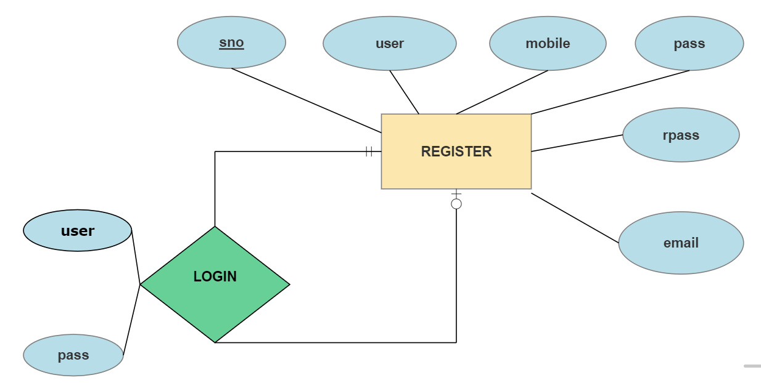

Figure 4.1 . Model ER Diagram of Heart Diagnoser [3].

**4.2 USE CASE DESCRIPTION**

### Login

#### Brief Description

This use case describes how a user logs into the Heart Diagnoser Registration System.

#### **Basic Flow**

This use case starts when an actor wishes to log into the Heart Diagnoser Registration System.

1. The system requests that the actor enter his/her username and password.
2. The actor enters his/her name and password.
3. The system validates the entered name and password and logs the actor into the system.
4. The system requests the input variables for predicting the result.
5. The actor enters the feature values.
6. The system predicts the results and display to user.

#### Alternative Flows

**Invalid Name / Password**  
If in the *Basic Flow*the actor enters an invalid name and/or password, the system displays an error message. The actor can choose to either return to the beginning of the *Basic Flow*or cancel the login, at which point the use case ends.

#### Pre-Conditions

None

#### Post-Conditions

If the use case was successful, the actor is now logged into the system. If not the system state is unchanged.

**4.3 USE CASE DIAGRAM**

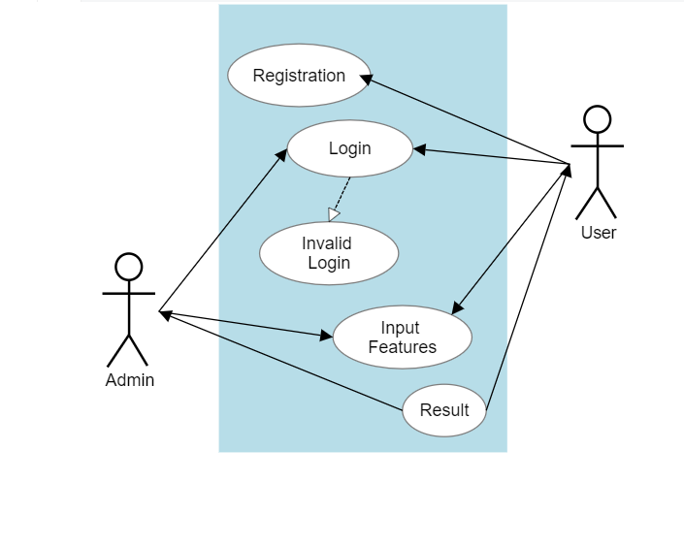

Figure 4.2. Use Case Diagram Login-Registration-Result System [3].

**4.4 DATAFLOW DIAGRAM**

A data flow diagram (DFD) is a graphical representation of the "flow" of data through an information system, modelling its process aspects. A DFD is often used as a preliminary step to create an overview of the system without going into great detail, DFDs can also be used for the visualization of data processing (structured design) [1].

A DFD shows what kind of information will be input to and output from the system, how the data will advance through the system and where the data will be stored.

The data flow diagram for Heart Diagnoser system has following 2 parts:

0 level data flow diagram

1 level data flow diagram

1. **LEVEL DFD:**

ADMIN

USER

DETAILS

GET INFO

MANAGE DATA

Diagnosing System

REPORT

Figure 4.3 0 Level DFD of Heart Diagnoser[3].

**1 LEVEL DFD:**

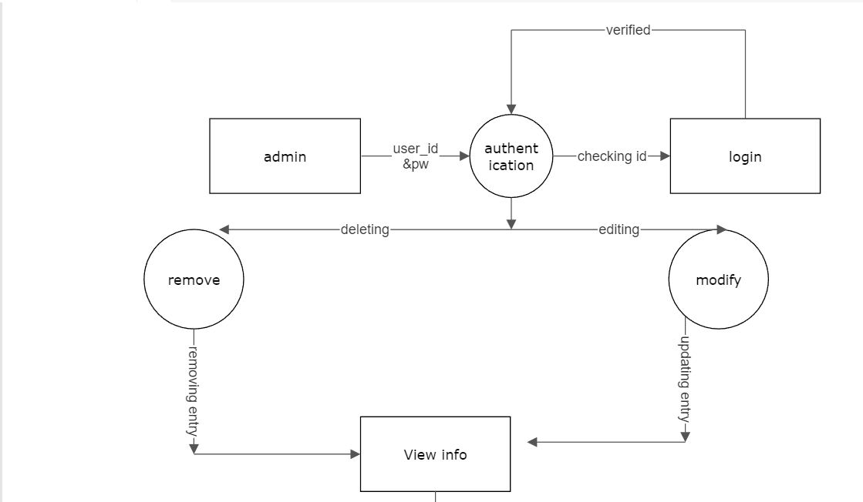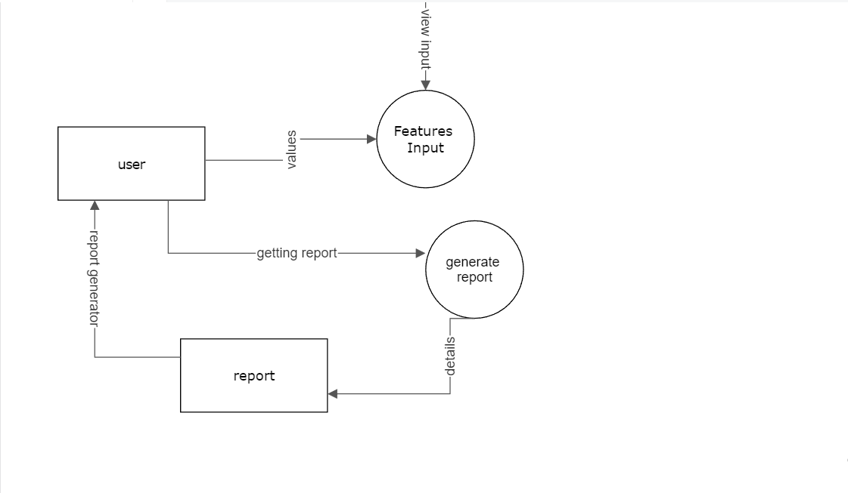

Figure 4. 4 1-Level DFD of Heart Diagnoser [3].

**4.5 SEQUENCE DIAGRAM**

A sequence diagram is **a Unified Modeling Language (UML) diagram that illustrates the sequence of messages between objects in an interaction**. A sequence diagram consists of a group of objects that are represented by lifelines, and the messages that they exchange over time during the interaction [10].

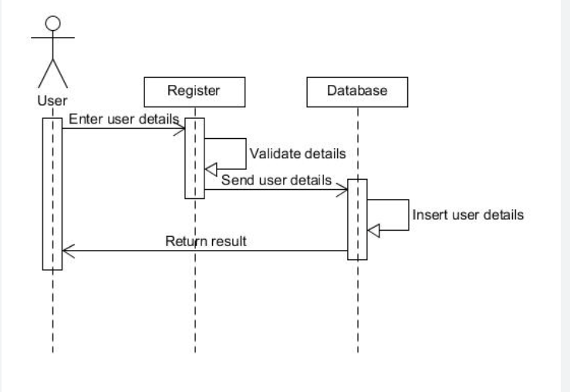

Figure 4.5. Client Server Sequence Diagram [3].

**4.6 USER INTERFACE**

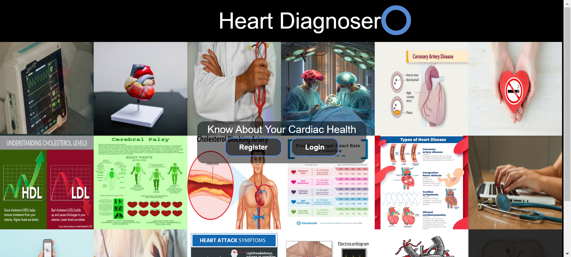

Figure 4.6. Index Page of Heart Diagnoser.

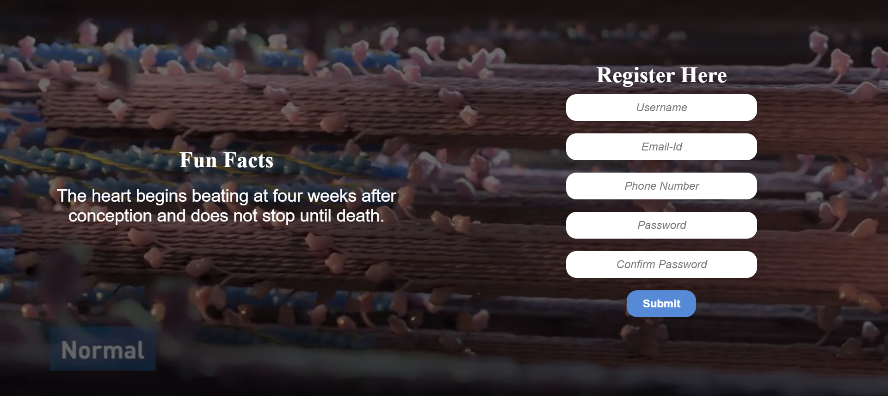

Figure 4.7. Register Page of Heart Diagnoser.

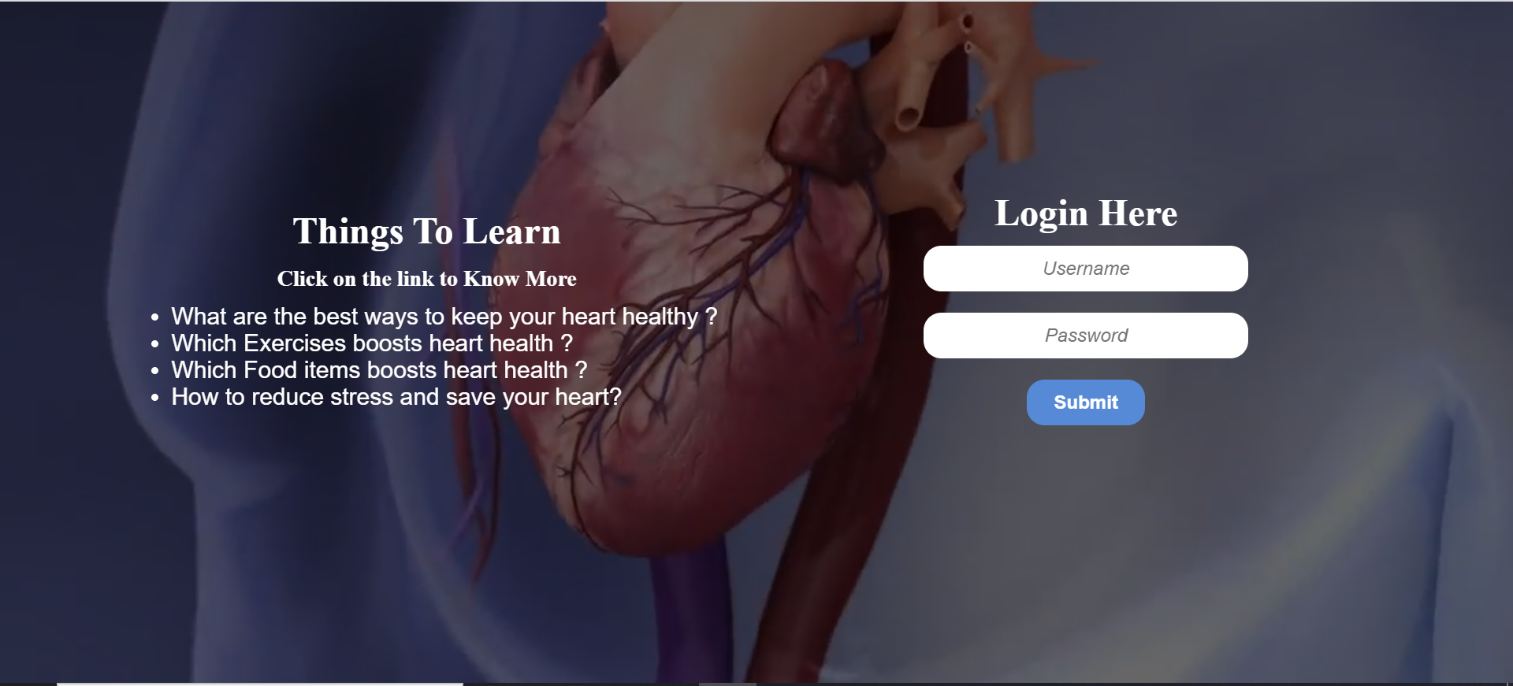

Figure 4.8. Login Page of Heart Diagnoser.

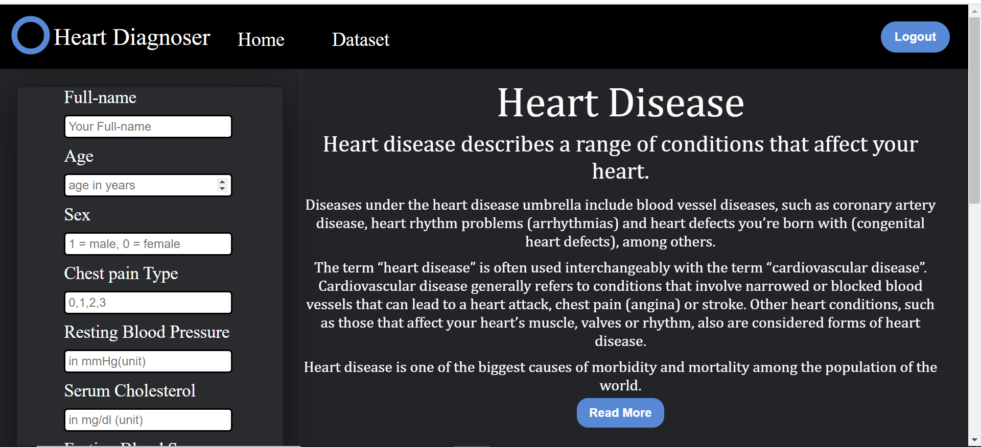 Figure 4.9. Home Page 1 of Heart Diagnoser.

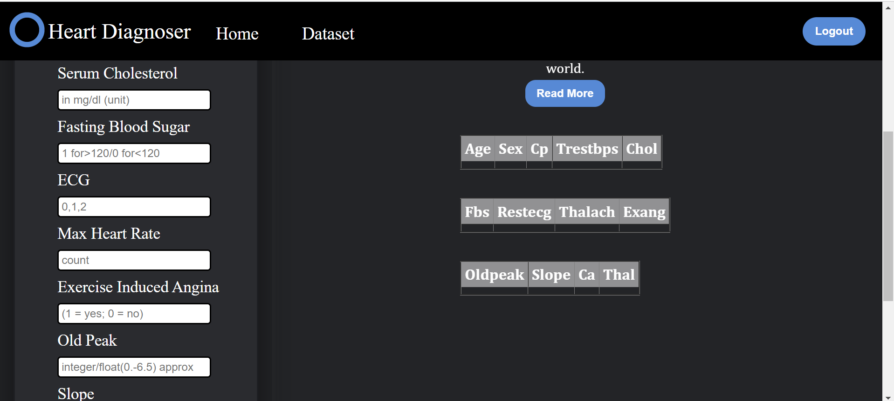­

Figure 4.10. Home Page 2 of Heart Diagnoser.

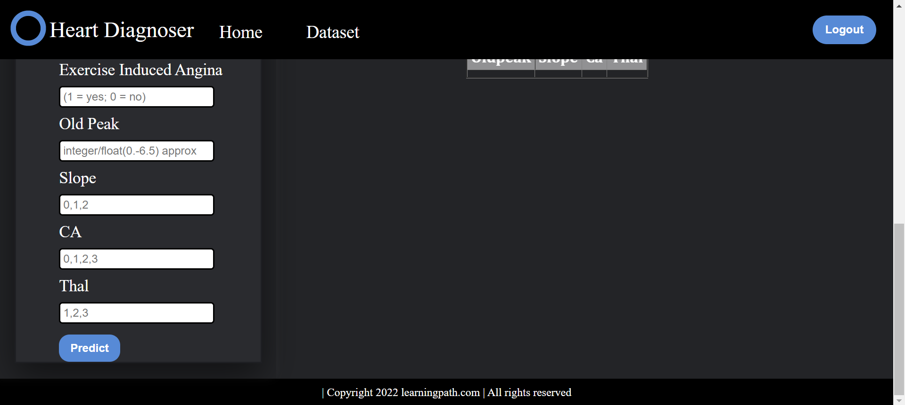

Figure 4.11. Home Page 3 of Heart Diagnoser.

**After Submission of Values:**

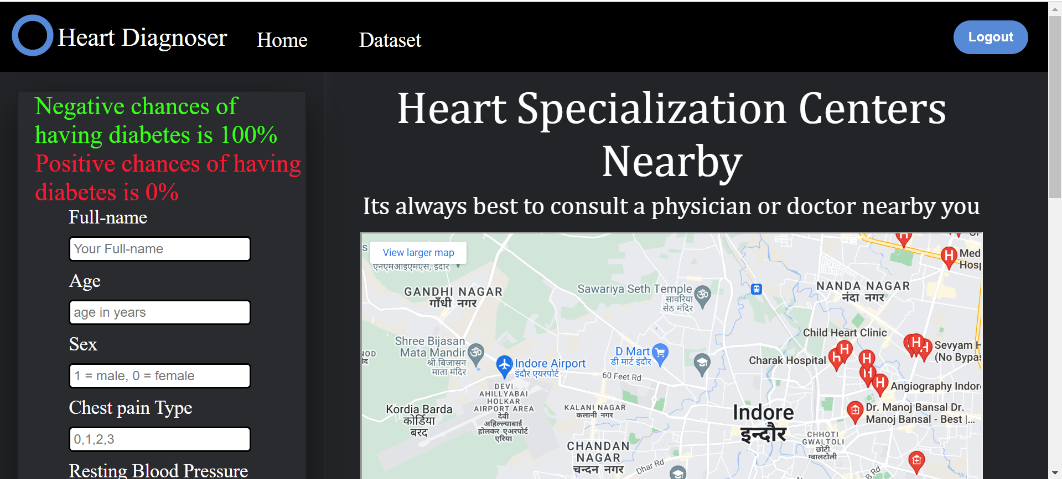

Figure 4.12. Home Page-predict- Page of Heart Diagnoser.

**Testing Values with Report Generation:**

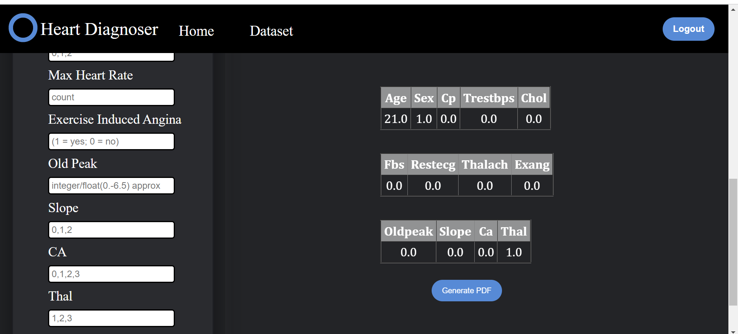

Figure 4.13. Predict Page –Generate Pdf.

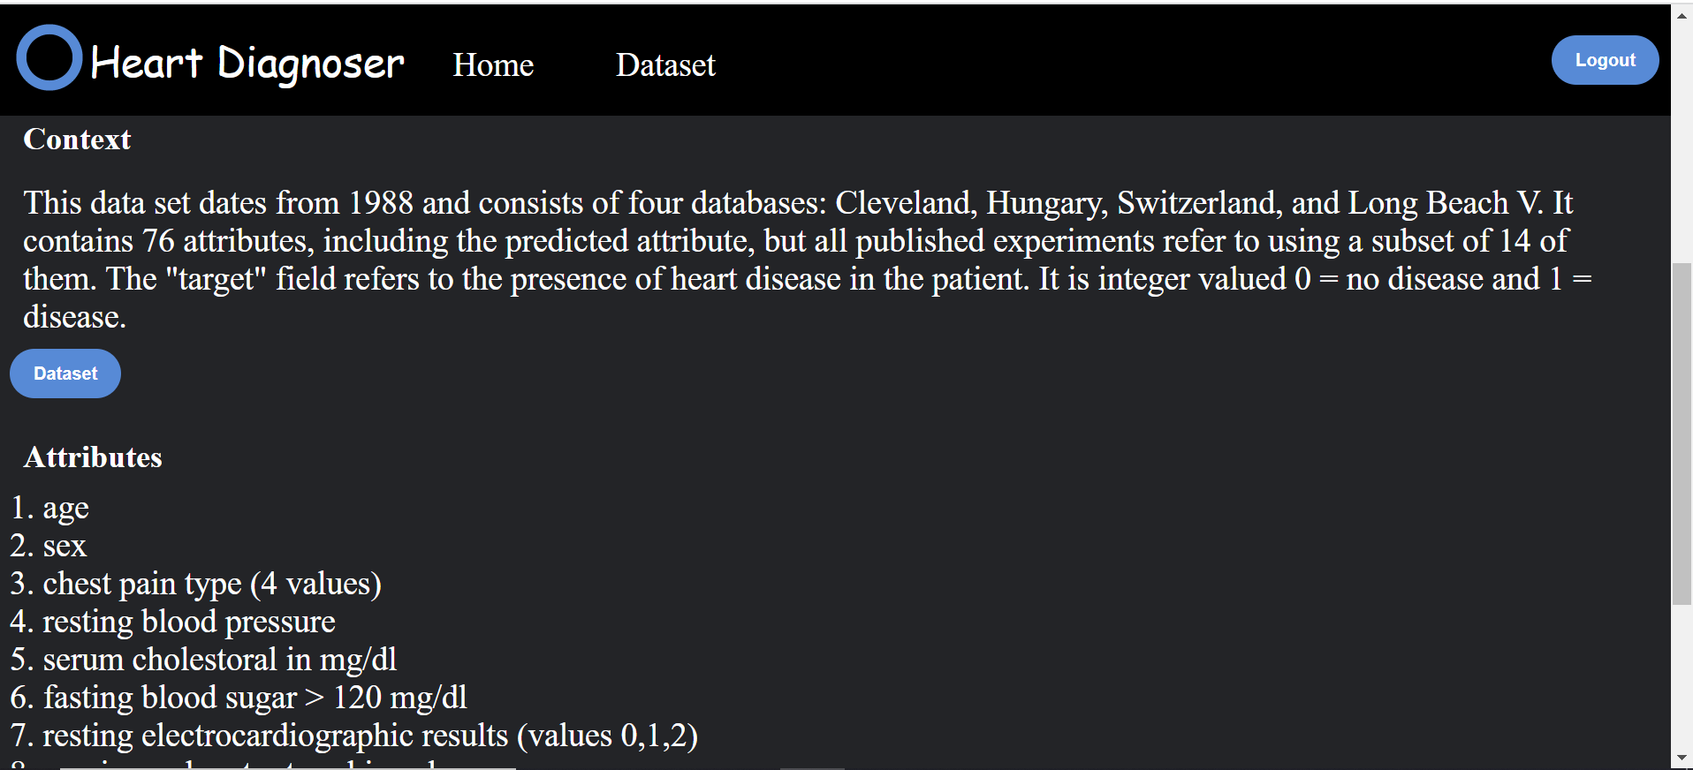

Figure 4.14. Dataset Page of Heart Diagnoser.

**Report:**

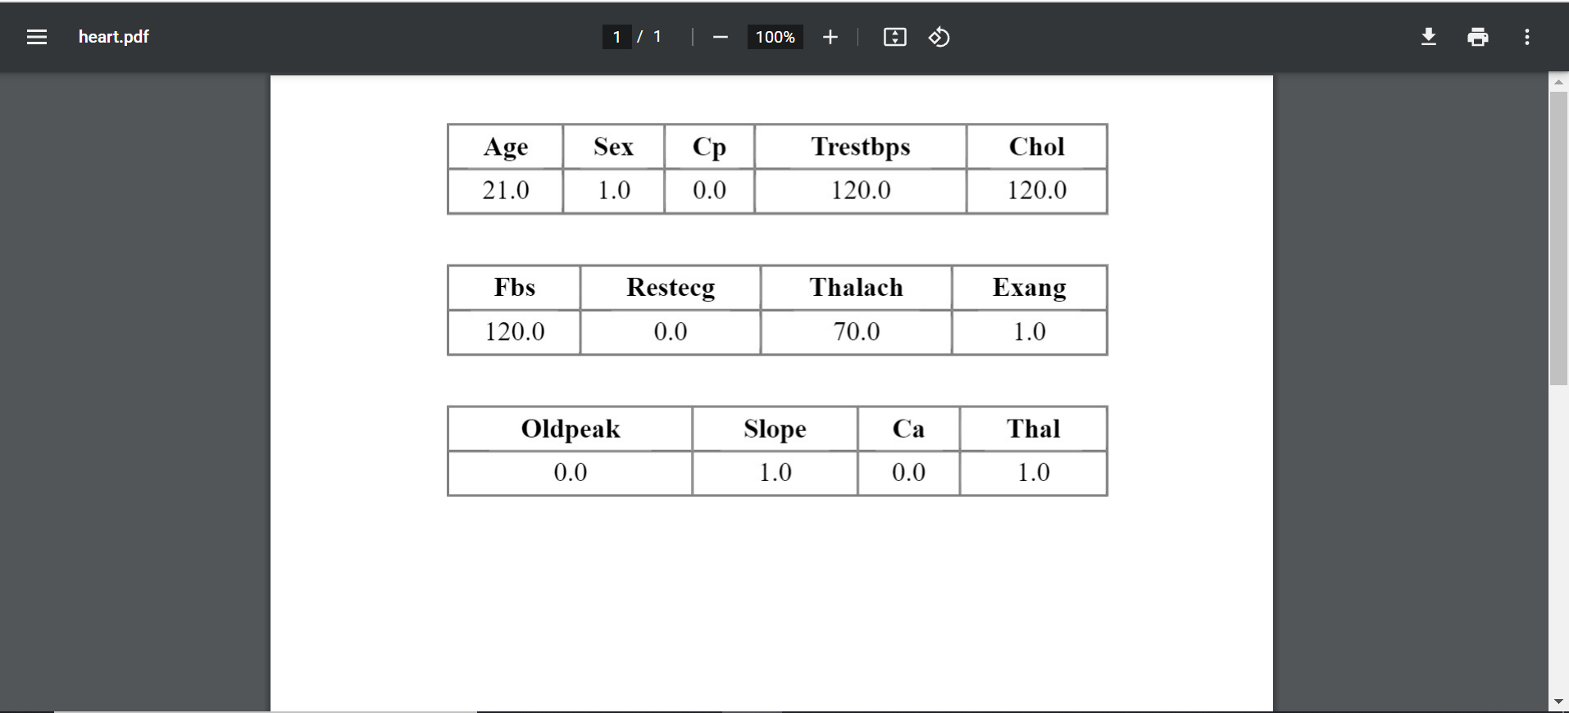

Figure 4.15. Report of Heart Diagnoser.

**5 System Testing**

**5.1 Preparation of Test Data**

**5.2 Black-Box Testing**

**5.3 White- Box Testing**

**5.4 Unit Testing**

**5.5 Integration Testing**

**5.6 System**

**5.7 Test Cases**

Testing should be done throughout the implementation process. Even before an application is installed, it makes sense to verify that the basic platform is capable of achieving its design capabilities. System testing is a critical process. Testing is a process of executing a program with the explicit intention of finding errors that is, making the program fail. This help in finding the bottlenecks in the system. Executing a program in a simulated environment performs testing. The feedback from testing phase generally produces changes in the software to deal with errors and failures that are uncovered. **[1]**

**5.1 PREPARATION OF TEST DATA**

## **About Dataset - KAGGLE**

### Context

This data set dates from 1988 and consists of four databases: Cleveland, Hungary, Switzerland, and Long Beach V. It contains 76 attributes, including the predicted attribute, but all published experiments refer to using a subset of 14 of them. The "target" field refers to the presence of heart disease in the patient. It is integer valued 0 = no disease and 1 = disease.[2]

**Link for Dataset:**

<https://www.kaggle.com/datasets/johnsmith88/heart-disease-dataset>

**5.2** **BLACK BOX TESTING:**

In Black Box testing or functional testing test cases are decided. Test cases are decided on the basis of the requirements or the specifications of the program or module.

Black Box testing is done in the project to remove the errors:

* Incorrect or missing function.
* Interface errors.
* Errors in data structures or external database access.
* Behavioral or performance error.
* Errors in initiation & termination.

**5.3 WHITE BOX TESTING:**

The White Box testing or Structural testing performs close operation of procedural details. They test the software logical path by having test cases exercising specific sets of conditions and loops.

* White Box testing is done in the project to remove the errors.
* All modules path has been exercised at least once.
* Exercised on logical decisions.
* Executed all loops at their boundaries and within their operational bounds.
* Exercised internal data structure to ensure their validity.

**5.4 UNIT TESTING:**

Unit testing focuses on verification efforts of the smallest grid of software designing i.e. a software component or module is tested. This testing is done at the coding phase. This testing uses procedural design as guide to test major controls path and uncovers errors within the module boundary.

Following tests were performed during unit test:

1. **Module Interface Testing:**

Module interface was tested to ensure information flow in and out of the program unit.

1. **Local Data Structure Testing:**

Local Data Structure were tested to ensure that data store temporally maintain their integrity during all steps in algorithm execution. were tested to make sure that the modules operate properly at

1. **Boundary Condition Test:**

Boundary Conditions were tested to make sure that the module operate properly at boundaries.

1. **Independent Path Test:**

All independent paths through control structure were checked to make sure that all statements in a module have been executed.

1. **Error Handling Path Test:**

Error handling path test was performed to handle exceptions.

**5.5 INTEGRATION TESTING:**

Integration testing is done to tackle the problem of interface i.e., putting all the interfaces together. When the separate modules are put together and work in an integrated manner, this testing is performed. This testing is a Systematic technique This testing is performed to check that data should not be lost across an interface.

The objective is to take unit tested modules and build a program structure that has been dictated by design.

Regression: Regression was done to ensure proper working of each module with the whole system. Each module was embedded in the system and the whole tested for integrity.

**5.6 SYSTEM TESTING:**

System testing is done when the entire system has been fully integrated. The purpose of the system testing is to test how the different modules interact with each other and whether the system provides the functionality that was expected

Security: Security was added to the system by making it password protected.

**5.7 TEST CASES**

|  |  |  |  |  |  |  |  |  |  |  |  |  |  |
| --- | --- | --- | --- | --- | --- | --- | --- | --- | --- | --- | --- | --- | --- |
| age | sex | cp | trestbps | chol | fbs | restecg | thalach | exang | oldpeak | slope | ca | thal | target |
| 52 | 1 | 0 | 125 | 212 | 0 | 1 | 168 | 0 | 1 | 2 | 2 | 3 | 0 |
| 53 | 1 | 0 | 140 | 203 | 1 | 0 | 155 | 1 | 3.1 | 0 | 0 | 3 | 0 |
| 70 | 1 | 0 | 145 | 174 | 0 | 1 | 125 | 1 | 2.6 | 0 | 0 | 3 | 0 |
| 61 | 1 | 0 | 148 | 203 | 0 | 1 | 161 | 0 | 0 | 2 | 1 | 3 | 0 |
| 62 | 0 | 0 | 138 | 294 | 1 | 1 | 106 | 0 | 1.9 | 1 | 3 | 2 | 0 |
| 58 | 0 | 0 | 100 | 248 | 0 | 0 | 122 | 0 | 1 | 1 | 0 | 2 | 1 |
| 58 | 1 | 0 | 114 | 318 | 0 | 2 | 140 | 0 | 4.4 | 0 | 3 | 1 | 0 |
| 55 | 1 | 0 | 160 | 289 | 0 | 0 | 145 | 1 | 0.8 | 1 | 1 | 3 | 0 |
| 46 | 1 | 0 | 120 | 249 | 0 | 0 | 144 | 0 | 0.8 | 2 | 0 | 3 | 0 |
| 54 | 1 | 0 | 122 | 286 | 0 | 0 | 116 | 1 | 3.2 | 1 | 2 | 2 | 0 |
| 71 | 0 | 0 | 112 | 149 | 0 | 1 | 125 | 0 | 1.6 | 1 | 0 | 2 | 1 |
| 43 | 0 | 0 | 132 | 341 | 1 | 0 | 136 | 1 | 3 | 1 | 0 | 3 | 0 |
| 34 | 0 | 1 | 118 | 210 | 0 | 1 | 192 | 0 | 0.7 | 2 | 0 | 2 | 1 |
| 51 | 1 | 0 | 140 | 298 | 0 | 1 | 122 | 1 | 4.2 | 1 | 3 | 3 | 0 |
| 52 | 1 | 0 | 128 | 204 | 1 | 1 | 156 | 1 | 1 | 1 | 0 | 0 | 0 |
| 34 | 0 | 1 | 118 | 210 | 0 | 1 | 192 | 0 | 0.7 | 2 | 0 | 2 | 1 |
| 51 | 0 | 2 | 140 | 308 | 0 | 0 | 142 | 0 | 1.5 | 2 | 1 | 2 | 1 |
| 54 | 1 | 0 | 124 | 266 | 0 | 0 | 109 | 1 | 2.2 | 1 | 1 | 3 | 0 |
| 50 | 0 | 1 | 120 | 244 | 0 | 1 | 162 | 0 | 1.1 | 2 | 0 | 2 | 1 |
| 58 | 1 | 2 | 140 | 211 | 1 | 0 | 165 | 0 | 0 | 2 | 0 | 2 | 1 |
| 60 | 1 | 2 | 140 | 185 | 0 | 0 | 155 | 0 | 3 | 1 | 0 | 2 | 0 |
|  |  |  |  |  |  |  |  |  |  |  |  |  |  |

Table No. 5.2 Test set

**6. Conclusions**

**6.1 Finding**

**6.1 FINDING**

The project entitled as Heart Diagnoser is the system that deals with the issues related to a particular medical disease.

• This project is successfully implemented with all the features mentioned in system requirements specification.

• The application provides appropriate information to users according to the chosen service.

• The project is designed keeping in view the problems faced by medicine practitioner.

• Deployment of our application will certainly help the hospitals and medical authorities to reduce unnecessary wastage of time. Correct information is necessary for patient health and practitioner So; this serves the right purpose in achieving the desired requirements of both the communities.

**7 Scope**

**7.1 Limitations**

**7.2 Scope for Future Prospects**

**7.1 LIMITATIONS**

1. 100 percent accuracy can’t be achieved in model.

**7.2 SCOPE FOR FUTURE PROSPECTS**

The project can be further expanding to many levels as:

* Project will be also made as android application.
* An extension of cancer, diabetes and other disease can be added to current system as universal health care system.
* We can also share data with government for health care precautions and testing.
* Many useful amendments can be made as we advance in time through technology. **[7]**

**8. BIBLIOGRAPHY & REFERENCES**

1. KNBH Hostel management project report
   1. Available: [https://ic9.in/838754](https://ic9.in/838754%20)
2. Kaggle heart dataset:
   1. Available: <https://www.kaggle.com/datasets/johnsmith88/heart-disease-dataset>
3. Smart Draw-Universal Diagram Creator:
   1. Available: <https://www.smartdraw.com>
4. SDLC – Overview
   1. Available: <https://cutt.ly/Hnk1p95>
5. How to Write a Website Project Report?
   1. Available: <https://cutt.ly/2nk1TdL>
6. What is a Software Requirements Specification document?
   1. Available: <https://cutt.ly/knk1Jo2>
7. What is a Project Scope? Write a Project Scope in 5 Steps | Adobe

Work front.

* 1. Available: https://cutt.ly/UnjGYkA

1. HTML,CSS :<https://www.w3schools.com/>
2. DBMS: <https://www.javatpoint.com/dbms-tutorial>
3. Sequence Diagram:

Available:https://www.ibm.com/docs/hr/rsas/7.5.0?topic=uml-sequence-diagrams